# Make a Game – Good Game Spawn Point

## Downloads

Everything you need for this lesson can be found at: <https://goo.gl/zcq5KF>

## Step 1: Bajo Movement



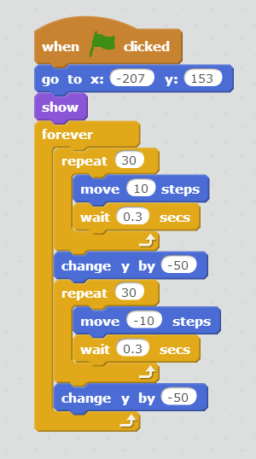

## Step 2: Hex Movement



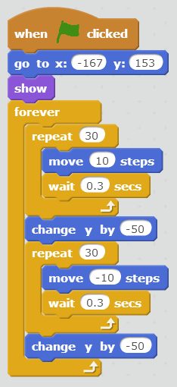

## Step 3: Goose Movement



